**Accessing Image Links**

Image links are the links in web pages represented by an image which when clicked navigates to a different window or page.

Since they are images, we cannot use the By.linkText() and By.partialLinkText() methods because image links basically have no link texts at all.

In this case, we should resort to using either By.cssSelector or By.xpath. The first method is more preferred because of its simplicity.

In the example below, we will access the “Facebook” logo on the upper left portion of Facebook’s Password Recovery page.

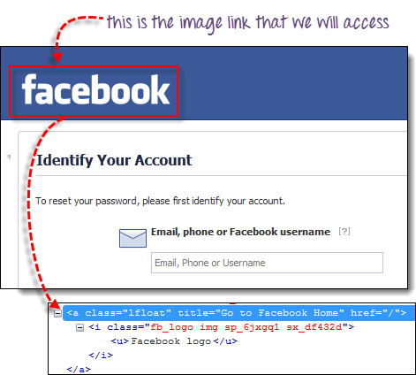

We will use By.cssSelector and the element’s “title” attribute to access the image link. And then we will verify if we are taken to Facebook’s homepage.

package newproject;

import org.openqa.selenium.By;

import org.openqa.selenium.WebDriver;

import org.openqa.selenium.chrome.ChromeDriver;

public class MyClass {

public static void main(String[] args) {

String baseUrl = "https://www.facebook.com/login/identify?ctx=recover";

System.setProperty("webdriver.chrome.driver","G:\\chromedriver.exe");

WebDriver driver = new ChromeDriver();

driver.get(baseUrl);

//click on the "Facebook" logo on the upper left portion

driver.findElement(By.cssSelector("a[title=\"Go to Facebook home\"]")).click();

//verify that we are now back on Facebook's homepage

if (driver.getTitle().equals("Facebook - log in or sign up")) {

System.out.println("We are back at Facebook's homepage");

} else {

System.out.println("We are NOT in Facebook's homepage");

}

driver.close();

}

}